Course: High Performance Computing Lab

Practical No 1

PRN: 22510003

Name: Akshat Mahajan

Batch: B5

Title: Introduction to OpenMP

Problem Statement 1 – Demonstrate Installation and Running of OpenMP code in C

Code:

Output :

Problem Statement 2 – Print ‘Hello, World’ in Sequential and Parallel in OpenMP

Code snapshot:

Output snapshot:

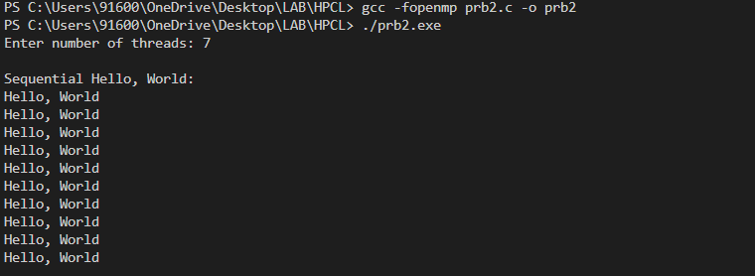

Analysis:

In sequential all run in a sequential manner so the order is in a synchronous manner but in case of parallel the order of execution is changed

GitHub Link: make a public repository upload code of an assignment and paste its link here.

Problem statement 3: Calculate theoretical FLOPS of your system on which you are running the above codes.

Code :

Output :

Elaborate the parameters and show calculation.

FLOPS=Cores×Clock Speed (Hz)×FLOPs/Cycle

**Realistic FLOPS (using physical cores=2)**

FLOPS=47.92 GFLOPS​

**Optimistic FLOPS (using logical processors = 4)**

95.84 GFLOPS​